Operating System:
An operating system is a system software that allows users or the application programs they are using to interact with the computer hardware in an easy and convenient manner.

The main functions (or views of operating system) of operating system are :
1. Operating System as extended machine or virtual machine:
generally, computer users sit in front of computer consisting of monitor, keyboard, mouse and system unit & use parts of computer system. E.g. I/O device, system unit, memory etc. The computer system is designed so that uses of resource to maximize the uses what is performing. In this case the operating system is designed mostly for easy with same attention paid for performance, the performance is important to the user but it does not matter, in most of the system is sitting idle, waiting for the slow i/o speed of the user. The operating system is design to maximize resource utilization.
The program that hides the truth about the hardware from the programmer and present a nice simple view of a named file that can be read & written as “operating system”. Operating system shields the programmer from the interface, the abstraction offers by the operating system is slower & easier to use than the underlying hardware.
The main function of operating system is to present the user with the equivalent of an extended machine or virtual machine that is easier to program than underlying hardware.
2. Operating system as resource manager:
Operating system is collection of software which is close to hardware. We can view operating system as a resource – hardware and software collector. A system has many hardware and software that may be required to solve the problem, CPU time, memory space, file storage space, i/o device etc. the operating system acts as manager of these resources.
Modern computer consists of processor, memories, times, disks, network, printer and wide varieties of other devices. The role of the operating system is to provide for an orderly and controlled allocation of the process, memories and I/O devices among the various programs competing for them.
An operating system is a control program, a control program manages the execution of user program to prevent errors and improve use of computer. It is especially concerned with the operation and control of I/O devices. When a computer has multiple users the operating system manages and protects the memory I/O devices. The operating system keeps in track that who is using which resource, to grant resource required amount for usage and to mediate conflicting required different programs and users.

3. Operating system as the program launcher :
It functions as the program launcher. If a user executes a program, the operating system locates it in the secondary storage, loads it in the main memory, and executes it.

Three main goals of the operating system:
1. The operating system should make the computer easy and convenient to use.
2. The operating system should manage the resources of the computer system to make them more efficient.
3. The operating system should execute and control programs.

All the functions of the operating system must be executed effectively in the background. The operating system must be executed when the computer is turned on. A bootstrap program stored in the computer’s read-only memory (ROM) is executed upon power on. Its main function is to perform power-on self test (POST) which checks if all the computer hardware are in good working condition. Another program called boot block loader locates the operating system and loads it in the main memory. At this point, the operating system takes charge of the computer system.

System Concepts:
Processes: A program in execution. If you run the same program twice, you have created two processes. For example if you have two editors running in two windows, each instance of the editor is a separate process.
Often one distinguishes the state or context (memory image, open files) from the thread of control. Then if one has many threads running in the same task, the result is a ``multithreaded processes''.
Files: Modern systems have a hierarchy of files. A file system tree.
In MSDOS the hierarchy is a forest not a tree. There is no file, or directory that is an ancestor of both a:\ and c:\.
In unix the existence of (hard) links weakens the tree to a DAG(directed acyclic graph).
Unix also has symbolic links, which when used indiscriminately, permit directed cycles (i.e., the result is not a DAG).
We can name a file via an absolute path starting at the root directory or via a relative path starting at the current working directory.
In addition to regular files and directories, Unix also uses the file system namespace for devices (called special files, which are typically found in the /dev directory. Often utilities that are normally applied to (ordinary) files can be applied as well to some special files. For example, when you are accessing a unix system using a mouse and do not have anything serious going on (e.g., right after you log in), type the following command
cat /dev/mouse
and then move the mouse. You kill the cat by typing cntl-C. I tried this on my linux box and no damage occurred. Your mileage may vary.
Before a file can be accessed, it must be opened and a file descriptor obtained. Many systems have standard files that are automatically made available to a process upon startup. These (initial) file descriptors are fixed
standard input: fd=0
standard output: fd=1
standard error: fd=2
A convenience offered by some command interpretors is a pipe or pipeline. The pipeline
dir | wc
which pipes the output dir into a character/word/line counter, will give the number of files in the directory (plus other info).

Shell: The Shell or Command Interpreter (DOS Prompt)
The command line interface to the operating system. The shell permits the user to
Invoke commands
Pass arguments to the commands
Redirect the output of a command to a file or device
Pipe one command to another (as illustrated above via ls | wc)

System calls: System calls are the way a user (i.e., a program) directly interfaces with the OS. Some textbooks use the term envelope for the component of the OS responsible for fielding system calls and dispatching them.

Security: Files and directories normally have permissions
Normally have at least rwx.
User, group, world
A more general mechanism is an access control lists.
Often files have ``attributes'' as well. For example the linux ext2 file system supports a ``d'' attribute that is a hint to the dump program not to backup this file.
When a file is opened, permissions are checked and, if the open is permitted, a file descriptor is returned that is used for subsequent operations

Operating System structure:
The structure of an operating system is dictated by the model employed in building them. An operating system model is a broad framework that unifies the many features and services the operating system provides and tasks it performs. Operating systems are broadly classified into following categories,
based on the their structuring mechanism as follows:
a. Monolithic System
b. Layered System
c. Virtual Machine
d. Exo-kernels
e. Client-Server Model
Monolithic systems:
- Functionality of the OS is invoked with simple function calls within the kernel, which is one large program
- Device drivers are loaded into the running kernel and become part of the kernel.

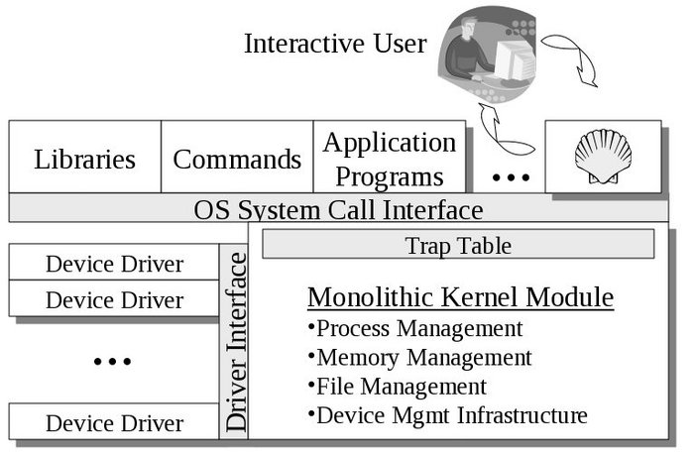
- A monolithic kernel, such as Linux and other Unix systems.

2. Layered Architecture:
- This approach breaks up the operating system into different layers.
- This allows implementers to change the inner workings, and increases modularity.
- As long as the external interface of the routines don’t change, developers have more freedom to change the inner workings of the routines.
- With the layered approach, the bottom layer is the hardware, while the highest layer is the user interface.
- The main advantage is simplicity of construction and debugging.
- The main difficulty is defining the various layers.
- The main disadvantage is that the OS tends to be less efficient than other implementations.
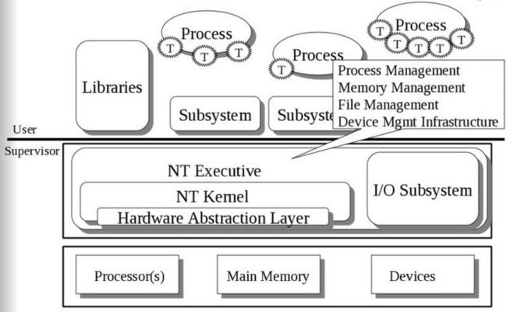
- The Microsoft Windows NT Operating System. The lowest level is a monolithic kernel, but many OS components are at a higher level, but still part of the OS.

3. Virtual Machine:
Virtual machine approach provides an interface that is identical to the underlying bare hardware. Each process is provided with a (virtual) copy of the underlying computer as shown in the fig. The resources of the physical computer are shared to create the virtual machine. CPU scheduling can be used to share the CPU and to create the appearance that users have their own processors.
Fig: a). Non Virtual Machine b). Virtual Machine.
Although the virtual machine concept is useful, it is difficult to implement. Much effort is required to provide an exact duplicate of the underlying machine.
Example. Java

4. Client-Server or Microkernel
The advent of new concepts in operating system design, microkernel, is aimed at migrating traditional services of an operating system out of the monolithic kernel into the user-level process. The idea is to divide the operating system into several processes, each of which implements a single set of services - for example, I/O servers, memory server, process server, threads interface system. Each server runs in user mode, provides services to the requested client. The client, which can be either another operating system component or application program, requests a service by sending a message to the server. An OS kernel (or microkernel) running in kernel mode delivers the message to the appropriate server; the server performs the operation; and microkernel delivers the results to the client in another message, as illustrated in Figure.
Fig: The client-server model.

Fig: The client-server model in a distributed system.

Evolution of Operating System:
1. Serial processing
2. Batch processing
3. Multiprogramming
4. Multitasking or time sharing System
5. Network Operating system
6. Distributed Operating system
7. Multiprocessor Operating System
8. Real Time Operating System
9. Modern Operating system

Serial Processing:
● Early computer from late 1940 to the mid 1950.
● The programmer interacted directly with the computer hardware.
● These machine are called bare machine as they don't have OS.
● Every computer system is programmed in its machine language.
● Uses Punch Card, paper tapes and language translator
These system presented two major problems.
1. Scheduling
2. Set up time:
Scheduling:
Used sign up sheet to reserve machine time. A user may sign up for an hour but finishes his job in 45 minutes. This would result in wasted computer idle time, also the user might run into the problem not finish his job in alloted time.
Set up time:
A single program involves:
● Loading compiler and source program in memory
● Saving the compiled program (object code)
● Loading and linking together object program and common function
Each of these steps involves the mounting or dismounting tapes on setting up punch cards. If an error occur user had to go the beginning of the set up sequence. Thus, a considerable amount of time is spent in setting up the program to run.
This mode of operation is turned as serial processing , reflecting the fact that users access the computer in series.

Simple Batch Processing:
● Early computers were very expensive, and therefore it was important to maximize processor utilization.
● The wasted time due to scheduling and setup time in Serial Processing was unacceptable.
● To improve utilization, the concept of a batch operating system was developed.
● Batch is defined as a group of jobs with similar needs. The operating system allows users to form batches. Computer executes each batch sequentially, processing all jobs of a batch considering them as a single process called batch processing.
The central idea behind the simple batch-processing scheme is the use of a piece of software known as the monitor. With this type of OS, the user no longer has direct access to the processor. Instead, the user submits the job on cards or tape to a computer operator, who batches the jobs together sequentially and places the entire batch on an input device, for use by the monitor. Each program is constructed to
branch back to the monitor when it completes processing, at which point the monitor automatically begins loading the next program.
With a batch operating system, processor time alternates between execution of user programs and execution of the monitor. There have been two sacrifices: Some main memory is now given over to the monitor and some processor time is consumed by the monitor. Both of these are forms of overhead.

Fig.: Memory Layout for resident memory

Multi-programmed Batch System:
A single program cannot keep either CPU or I/O devices busy at all times. Multiprogramming increases CPU utilization by organizing jobs in such a manner that CPU has always one job to execute. If computer is required to run several programs at the same time, the processor could be kept busy for the most of the time by switching its attention from one program to the next. Additionally I/O transfer could overlap the processor activity i.e, while one program is awaiting for an I/O transfer, another program can use the processor. So CPU never sits idle or if comes in idle state then after a very small time it is again busy. This is illustrated in fig below.

Fig : Multiprogramming example

Multitasking or Time Sharing System:
● Multiprogramming didn't provide the user interaction with the computer system.
● Time sharing or Multitasking is a logical extension of Multiprogramming that provides user interaction.
● There are more than one user interacting the system at the same time
● The switching of CPU between two users is so fast that it gives the impression to user that he is only working on the system but actually it is shared among different users.
● CPU bound is divided into different time slots depending upon the number of users using the system.
● just as multiprogramming allows the processor to handle multiple batch jobs at a time, multiprogramming can also be used to handle multiple interactive jobs. In this latter case, the technique is referred to as time sharing, because processor time is shared among multiple users
● A multitasking system uses CPU scheduling and multiprogramming to provide each user with a small portion of a time shared computer. Each user has at least one separate program in memory.
● Multitasking are more complex than multiprogramming and must provide a mechanism for jobs synchronization and communication and it may ensure that system does not go in deadlock.
Although batch processing is still in use but most of the system today available uses the concept of multitasking and Multiprogramming.

Distributed System:
Multiprocessor system:
- General term for the use of two or more CPUs for a computer system.
- Can vary with context, mostly as a function of how CPUs are defined.
- The term multiprocessing is sometimes used to refer to the execution of multiple concurrent software processes in a system as opposed to a single process at any one instant.
Multiprogramming:
Multiprogramming is more appropriate to describe concept which is implemented mostly in software, whereas multiprocessing is more appropriate to describe the use of multiple hardware CPUs.
A system can be both multiprocessing and multiprogramming, only one of the two or neither of the two.
Processor Coupling:
Its the logical connection of the CPUs. Multiprocessor system have more than one processing unit sharing memory/peripherals devices. They have greater computing power and higher reliability.
Multiprocessor system can be classified into two types:
1. Tightly coupled
2. Loosely coupled (distributed). Each processor has its own memory and copy of the OS.
Tightly Coupled (Multi-processor System): Tightly coupled multiprocessor system contains multiple CPUs that are connected at the bus level. Each processor is assigned a specific duty but processor work in close association, possibly sharing one memory module.
chip multiprocessors also known as multi-core computing involves more than one processor placed on a single chip and can be thought as the most extreme form of tightly coupled multiprogramming.
Dual core, Core-2 Duo, Intel Core I5 etc are the brand name used for various mid-range to high end consumers and business multiprocessor made by Intel.
Loosely Coupled (Distributed System):
Loosely coupled system often referred to as clusters are based on multiple stand-alone single or dual processors commodity computers interconnected via a high speed communication system. Distributed systems are connected via a distributed operating system.
Multiprocessor operating system:
Multiprocessor operating system aims to support high performance through the use of multiple CPUs.
It consists of a set of processors that share a set of physical memory blocks over an interconnected network. An important goal is to make the number of CPUs transparent to the application. Achieving such transparency is relatively easy because the communication between different (parts of ) application uses the same primitives as those in Uni - processor OS.
The idea is that all communication is done by manipulating data at the shared memory locations and that we only have to protect that data segment against simultaneous access. Protection is done through synchronization primitives like semaphores and monitors.
Fig: Multiprocessor System.

Distributed Operating System:
A recent trend in computer system is to distribute computation among several processors. In contrasts to the tightly coupled system the processors do not share memory or a clock. Instead, each processor has its own local memory. The processors communicate with one another through various communication lines such as computer network. Distributed operating system is the operating system
for a distributed system( a network of autonomous computers connected by a communication network through a message passing mechanisms). A distributed operating system controls and manages the hardware and software resources of a distributed system. When a program is executed on a distributed system, user is not aware of where the program is executed or the location of the resources accessed.
Fig: Architecture of a Distributed system.
Example of Distributed OS: Amoeba, Chorus, Alpha Kernel.

Real Time Operating System:
Primary objective of Real Time Operating System is to provide quick response time and thus to meet a scheduling deadline. User convenience and resource utilization are secondary concern to these systems.
Real time system has many events that must be accepted and processed in a short time or within certain deadline. Such applications include Rocket launching, flight control, robotics, real time simulation, Telephone switching equipments etc.
Real time systems are classified into two categories:
a). Soft Real time System: If certain deadlines are missed then system continues its working with no failure but its performance degrade.
b). Hard Real time System: If any deadline is missed then system will fail to work or does not work properly. This system guarantees that critical task is completed on time.

